Below are the screenshots for the UI screens that are developed in Sprint-8:

For Registration Preview: (Link for VD: https://xd.adobe.com/spec/44a149c6-a386-4f59-5366-f7af16869c24-3290/screen/c3cf06da-aa86-43c7-a048-67bd22012c95/11-Registration-Preview/)

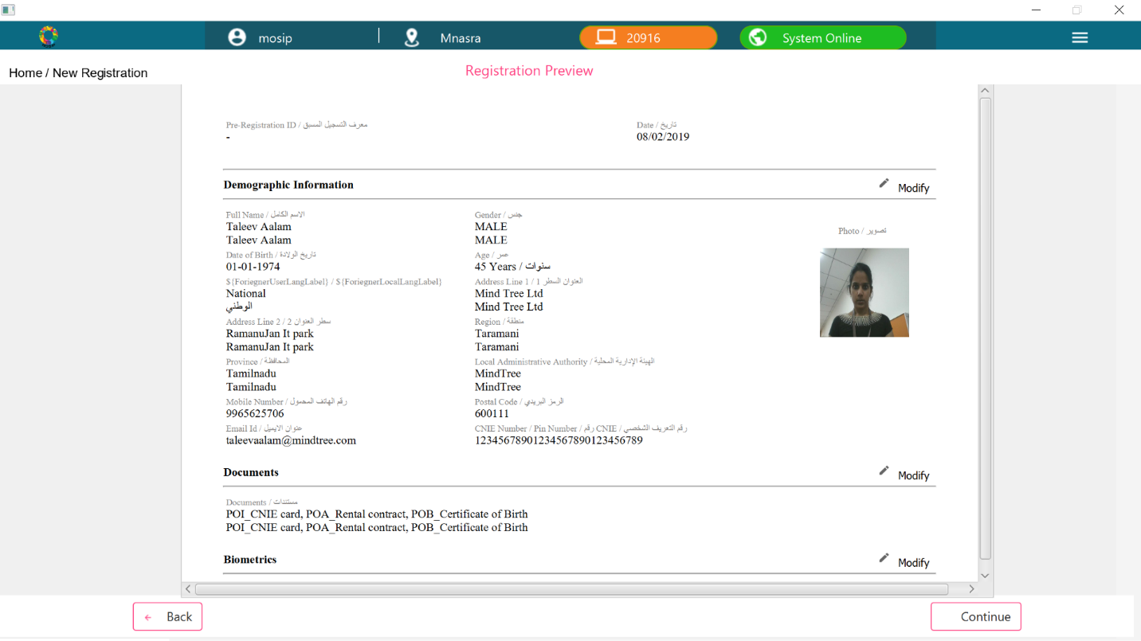

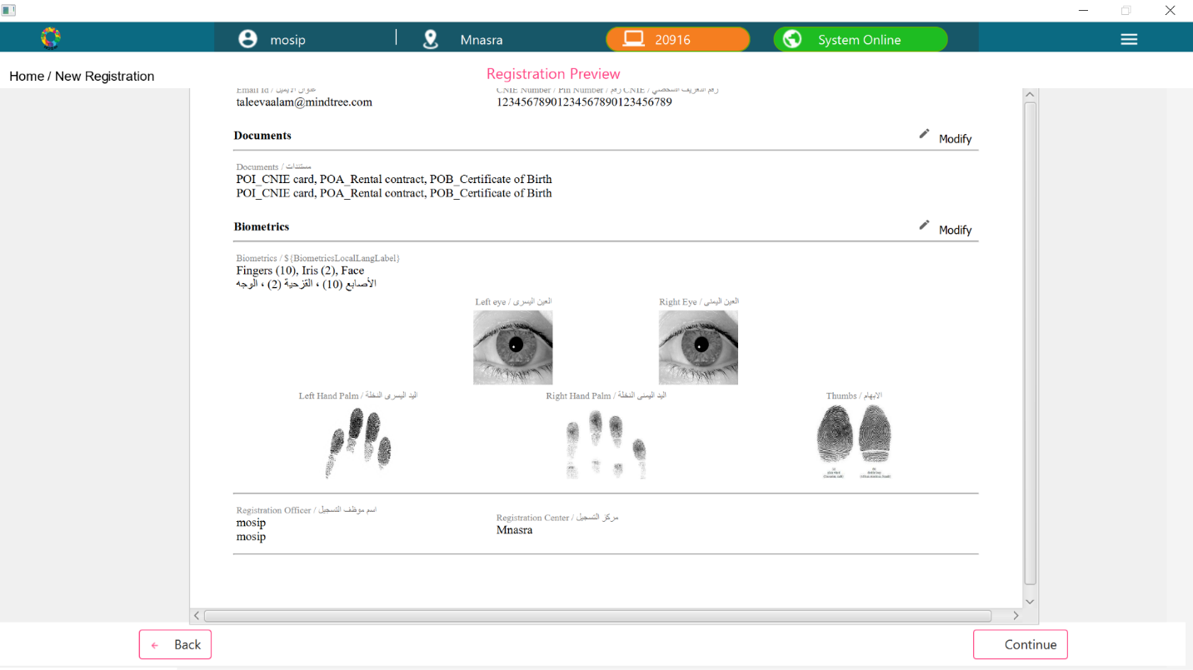

For Registration Acknowledgement: (Link for VD: https://xd.adobe.com/spec/44a149c6-a386-4f59-5366-f7af16869c24-3290/screen/e2f618ed-aecf-4b7a-9284-a74b94de7771/11-acknowledgement/)

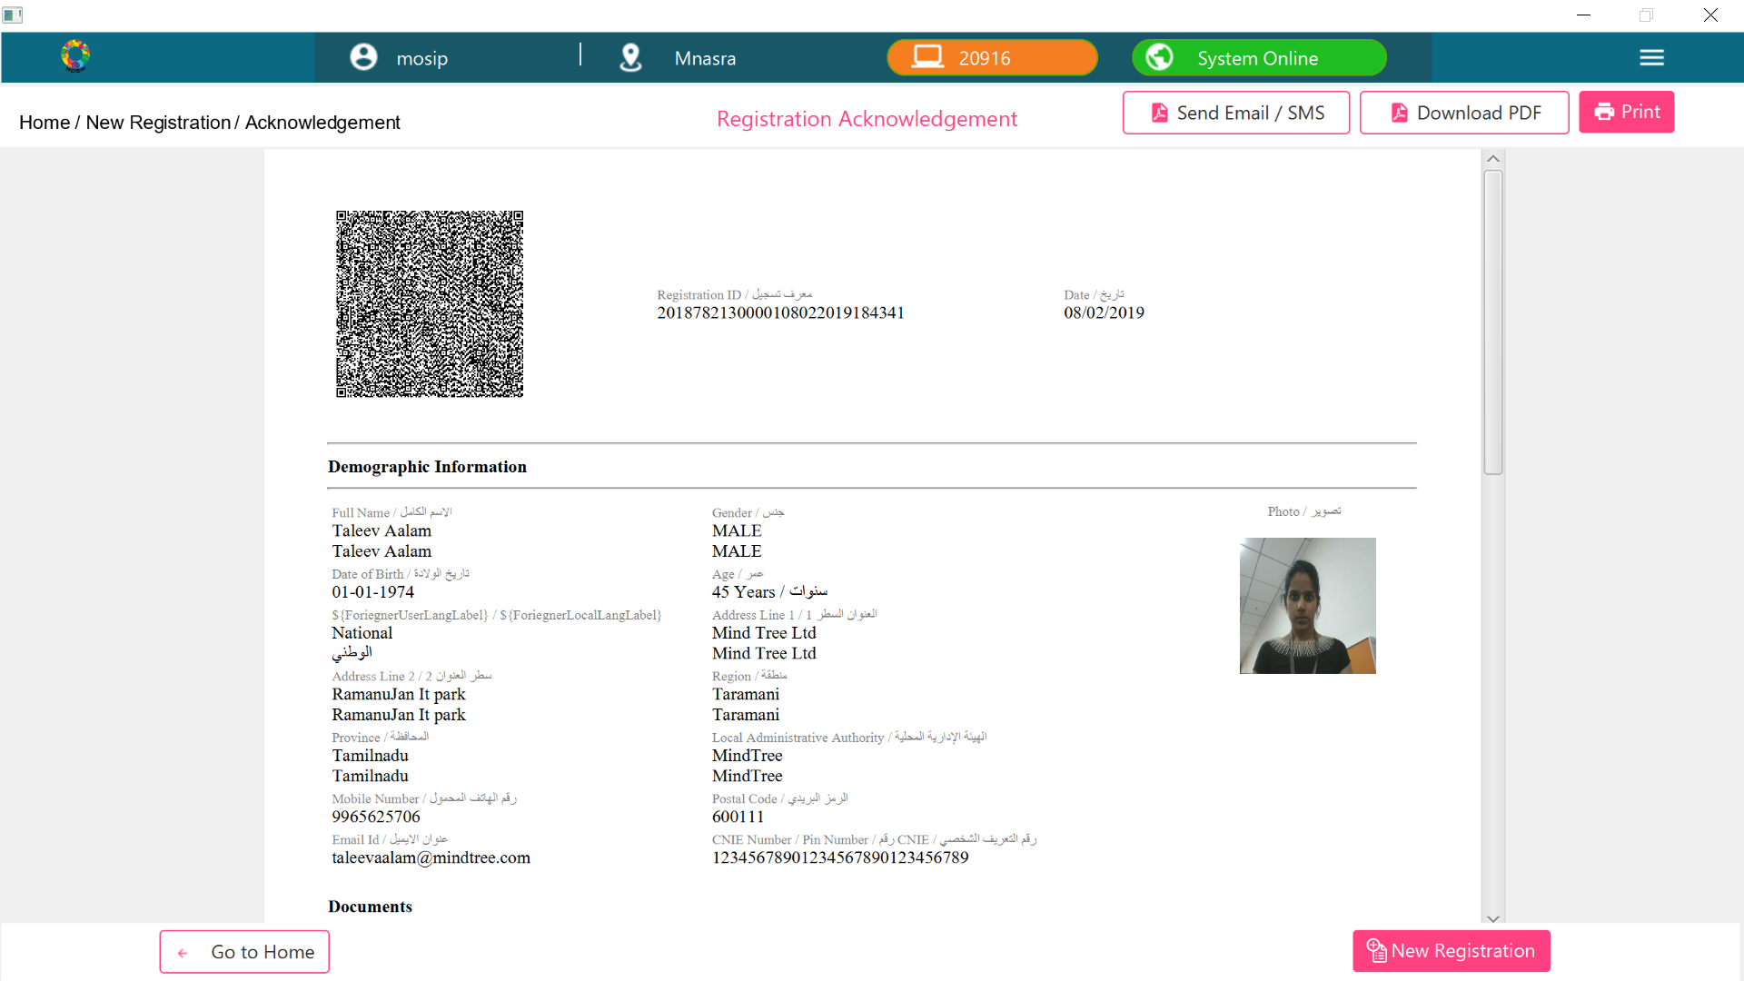

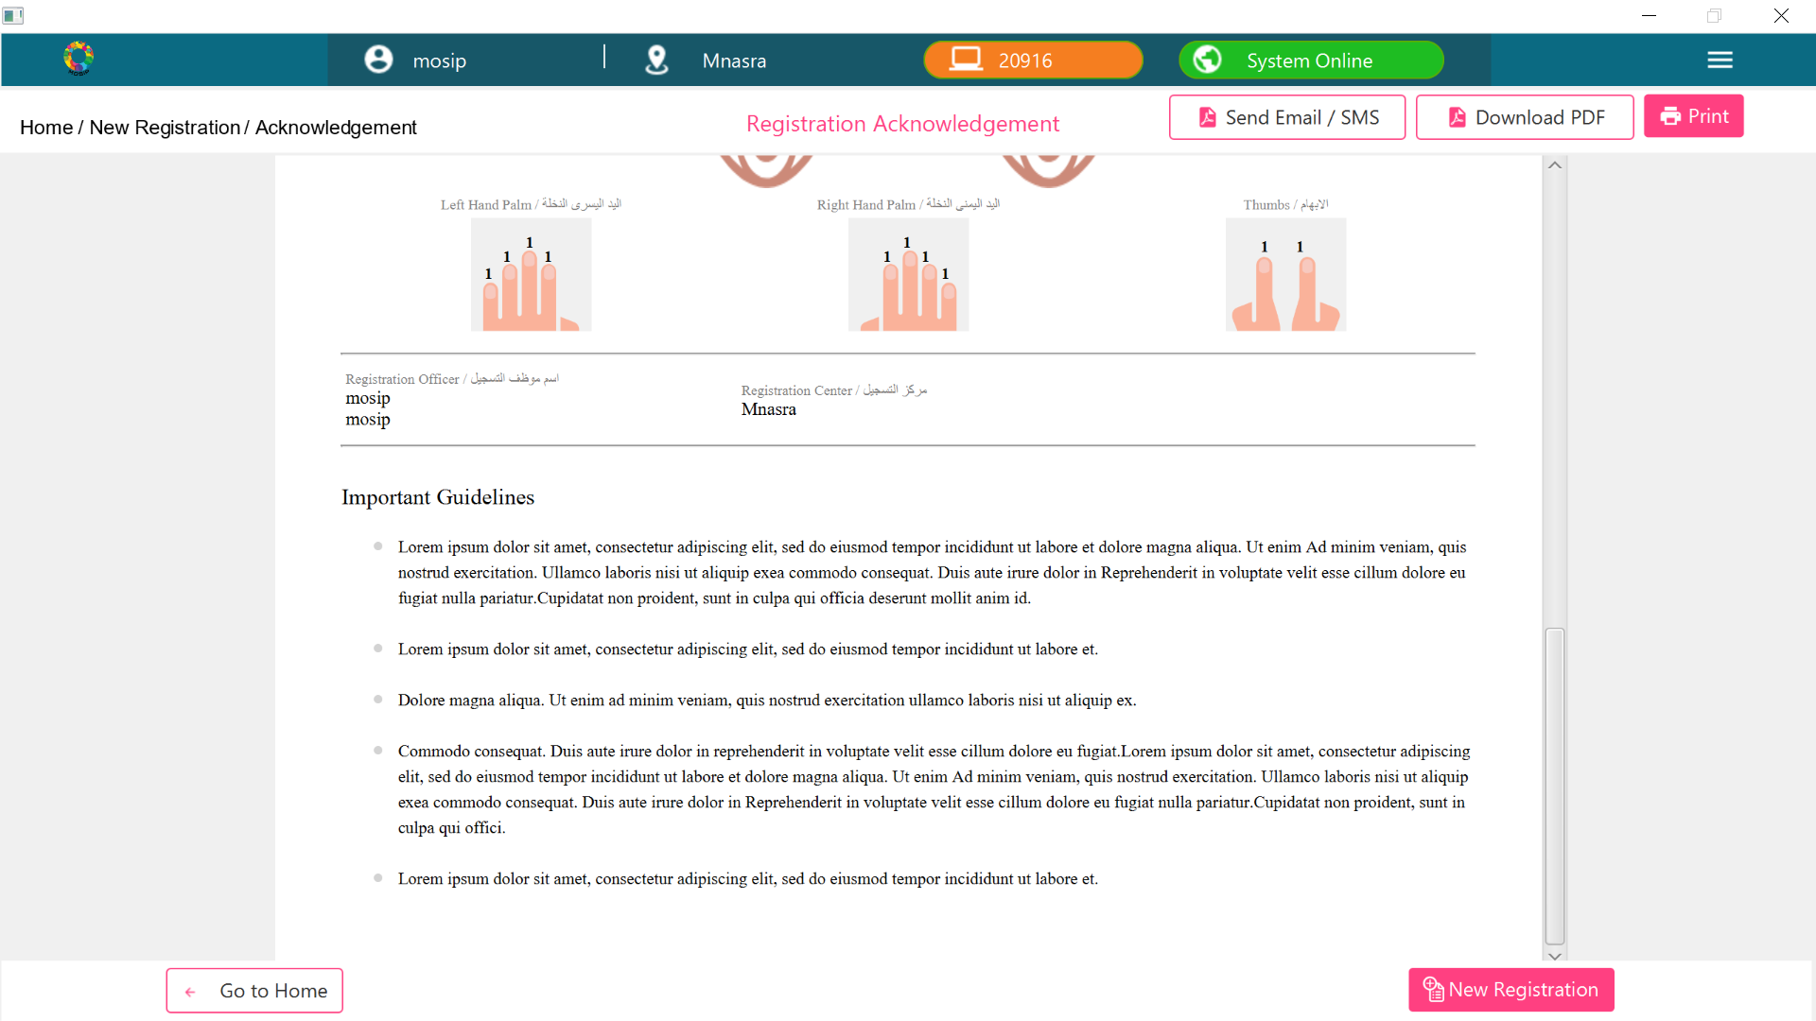

For Email/SMS Notification: (VD Link: https://xd.adobe.com/spec/69003b24-ed0e-4531-423e-d6e0fb27141e-1f31/screen/534de015-7241-4146-ad47-cdaaf3b53a04/send-email-sms-modal/)

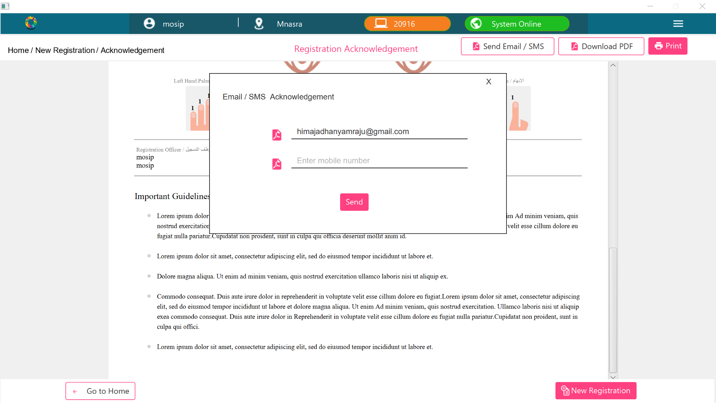

For EOD Packet Approval: (VD Link: https://xd.adobe.com/spec/69003b24-ed0e-4531-423e-d6e0fb27141e-1f31/screen/7edadf4c-20e1-4cb4-8be4-e5ae0cc44ca1/03-Pending-Approval/)

